MED D - Test Claim - Calculating Quantity of Vaccines

Definition | A Vaccine is a product that stimulates a person's immune system to produce immunity to a specific disease, protecting the person from that disease. Vaccines are usually administered through needle injections but can also be administered by mouth or sprayed into the nose.
Instructions for Running a Test Claim | No additional information.
Additional Notes | PeopleSafe by default will show you the Package Size, use this to run your test claim for a Retail 30-day supply.  Note: Do not run a test claim for vaccines unless pharmacy coverage is indicated in the CIF for the vaccine.
What if Test Claim Rejects | Review the rejection code to determine what caused the rejection. Once the rejection code is identified, access the proper work instruction and job aids in theSource to help you resolve the issue.

Example
Pneumovax
25/0.5

Directions: As directed
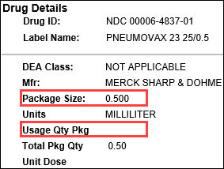 | 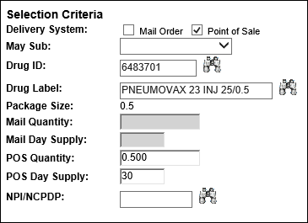
Calculation
No calculation needed. Enter quantity of 0.5 for 30 day supply.

Top of the Document

Related Documents
MED D - Test Claim Index
MED D – Vaccines

Parent SOP: CALL-0049: Customer Care Internal and External Call Handling
Abbreviations / Definitions: Customer Care Abbreviations, Definitions, and Terms

Top of the Document

Not To Be Reproduced Or Disclosed to Others Without Prior Written Approval
ELECTRONIC DATA = OFFICIAL VERSION – PAPER COPY – INFORMATIONAL ONLY

